CREACIÓN DE BASE DE DATOS EN POSTGRESQL:

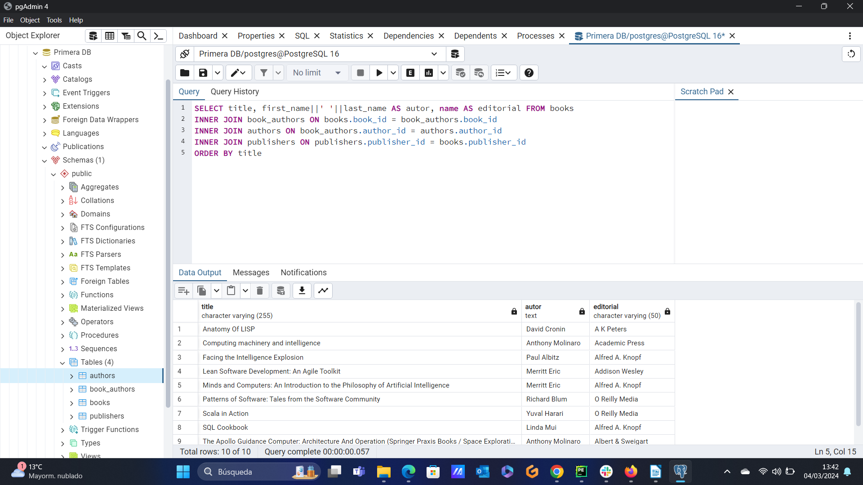

CREATE TABLE publishers(
publisher_id INT NOT NULL,
name VARCHAR(255) NOT NULL,
PRIMARY KEY(publisher_id)
);

CREATE TABLE authors(
author_id INT NOT NULL,
first_name VARCHAR(100) NOT NULL,
middle_name VARCHAR(50) NULL,
last_name VARCHAR(100) NULL,
PRIMARY KEY(author_id)
);

CREATE TABLE books(
book_id INT NOT NULL,
title VARCHAR(255) NOT NULL,
total_pages INT NULL,
rating DECIMAL(4, 2) NULL,
isbn VARCHAR(13) NULL,
published_date DATE,
publisher_id INT NULL,
PRIMARY KEY(book_id),
CONSTRAINT fk_publisher FOREIGN KEY(publisher_id) REFERENCES publishers(publisher_id)
);

CREATE TABLE book_authors (
book_id INT NOT NULL,
author_id INT NOT NULL,
PRIMARY KEY(book_id, author_id),
CONSTRAINT fk_book FOREIGN KEY(book_id) REFERENCES books(book_id) ON DELETE CASCADE,
CONSTRAINT fk_author FOREIGN KEY(author_id) REFERENCES authors(author_id) ON DELETE CASCADE
);
- publishers
INSERT INTO publishers(publisher_id, name) VALUES (1, 'O Reilly Media');
INSERT INTO publishers(publisher_id, name) VALUES (2, 'A Book Apart');
INSERT INTO publishers(publisher_id, name) VALUES (3, 'A K PETERS');
INSERT INTO publishers(publisher_id, name) VALUES (4, 'Academic Press');
INSERT INTO publishers(publisher_id, name) VALUES (5, 'Addison Wesley');
INSERT INTO publishers(publisher_id, name) VALUES (6, 'Albert&Sweigart');
INSERT INTO publishers(publisher_id, name) VALUES (7, 'Alfred A. Knopf');

-- authors
INSERT INTO authors (author_id, first_name, middle_name, last_name) VALUES (1, 'Merritt', null, 'Eric');
INSERT INTO authors (author_id, first_name, middle_name, last_name) VALUES (2, 'Linda', null, 'Mui');
INSERT INTO authors (author_id, first_name, middle_name, last_name) VALUES (3, 'Alecos', null, 'Papadatos');
INSERT INTO authors (author_id, first_name, middle_name, last_name) VALUES (4, 'Anthony', null, 'Molinaro');
INSERT INTO authors (author_id, first_name, middle_name, last_name) VALUES (5, 'David', null, 'Cronin');
INSERT INTO authors (author_id, first_name, middle_name, last_name) VALUES (6, 'Richard', null, 'Blum');
INSERT INTO authors (author_id, first_name, middle_name, last_name) VALUES (7, 'Yuval', 'Noah', 'Harari');
INSERT INTO authors (author_id, first_name, middle_name, last_name) VALUES (8, 'Paul', null, 'Albitz');

-- books
INSERT INTO books (book_id, title, total_pages, rating, isbn, published_date, publisher_id) VALUES (1, 'Lean Software Development: An Agile Toolkit', 240, 4.17, '9780320000000', '2003-05-18', 5);
INSERT INTO books (book_id, title, total_pages, rating, isbn, published_date, publisher_id) VALUES (2, 'Facing the Intelligence Explosion', 91, 3.87, null, '2013-02-01', 7);
INSERT INTO books (book_id, title, total_pages, rating, isbn, published_date, publisher_id) VALUES (3, 'Scala in Action', 419, 3.74, '9781940000000', '2013-04-10', 1);
INSERT INTO books (book_id, title, total_pages, rating, isbn, published_date, publisher_id) VALUES (4, 'Patterns of Software: Tales from the Software Community', 256, 3.84, '9780200000000', '1996-08-15', 1);
INSERT INTO books (book_id, title, total_pages, rating, isbn, published_date, publisher_id) VALUES (5, 'Anatomy Of LISP', 446, 4.43, '9780070000000', '1978-01-01', 3);
INSERT INTO books (book_id, title, total_pages, rating, isbn, published_date, publisher_id) VALUES (6, 'Computing machinery and intelligence', 24, 4.17, null, '2009-03-22', 4);
INSERT INTO books (book_id, title, total_pages, rating, isbn, published_date, publisher_id) VALUES (7, 'XML: Visual QuickStart Guide', 269, 3.66, '9780320000000', '2009-01-01', 5);
INSERT INTO books (book_id, title, total_pages, rating, isbn, published_date, publisher_id) VALUES (8, 'SQL Cookbook', 595, 3.95, '9780600000000', '2005-12-01', 7);
INSERT INTO books (book_id, title, total_pages, rating, isbn, published_date, publisher_id) VALUES (9, 'The Apollo Guidance Computer: Architecture And Operation (Springer Praxis Books / Space Exploration)', 439, 4.29, '9781440000000', '2010-07-01', 6);
INSERT INTO books (book_id, title, total_pages, rating, isbn, published_date, publisher_id) VALUES (10, 'Minds and Computers: An Introduction to the Philosophy of Artificial Intelligence', 222, 3.54, '9780750000000', '2007-02-13', 7);

-- book authors
INSERT INTO book_authors (book_id, author_id) VALUES (1, 1);
INSERT INTO book_authors (book_id, author_id) VALUES (2, 8);
INSERT INTO book_authors (book_id, author_id) VALUES (3, 7);
INSERT INTO book_authors (book_id, author_id) VALUES (4, 6);
INSERT INTO book_authors (book_id, author_id) VALUES (5, 5);
INSERT INTO book_authors (book_id, author_id) VALUES (6, 4);
INSERT INTO book_authors (book_id, author_id) VALUES (7, 3);
INSERT INTO book_authors (book_id, author_id) VALUES (8, 2);
INSERT INTO book_authors (book_id, author_id) VALUES (9, 4);
INSERT INTO book_authors (book_id, author_id) VALUES (10, 1);

HISTORIAL DE CONSULTAS:

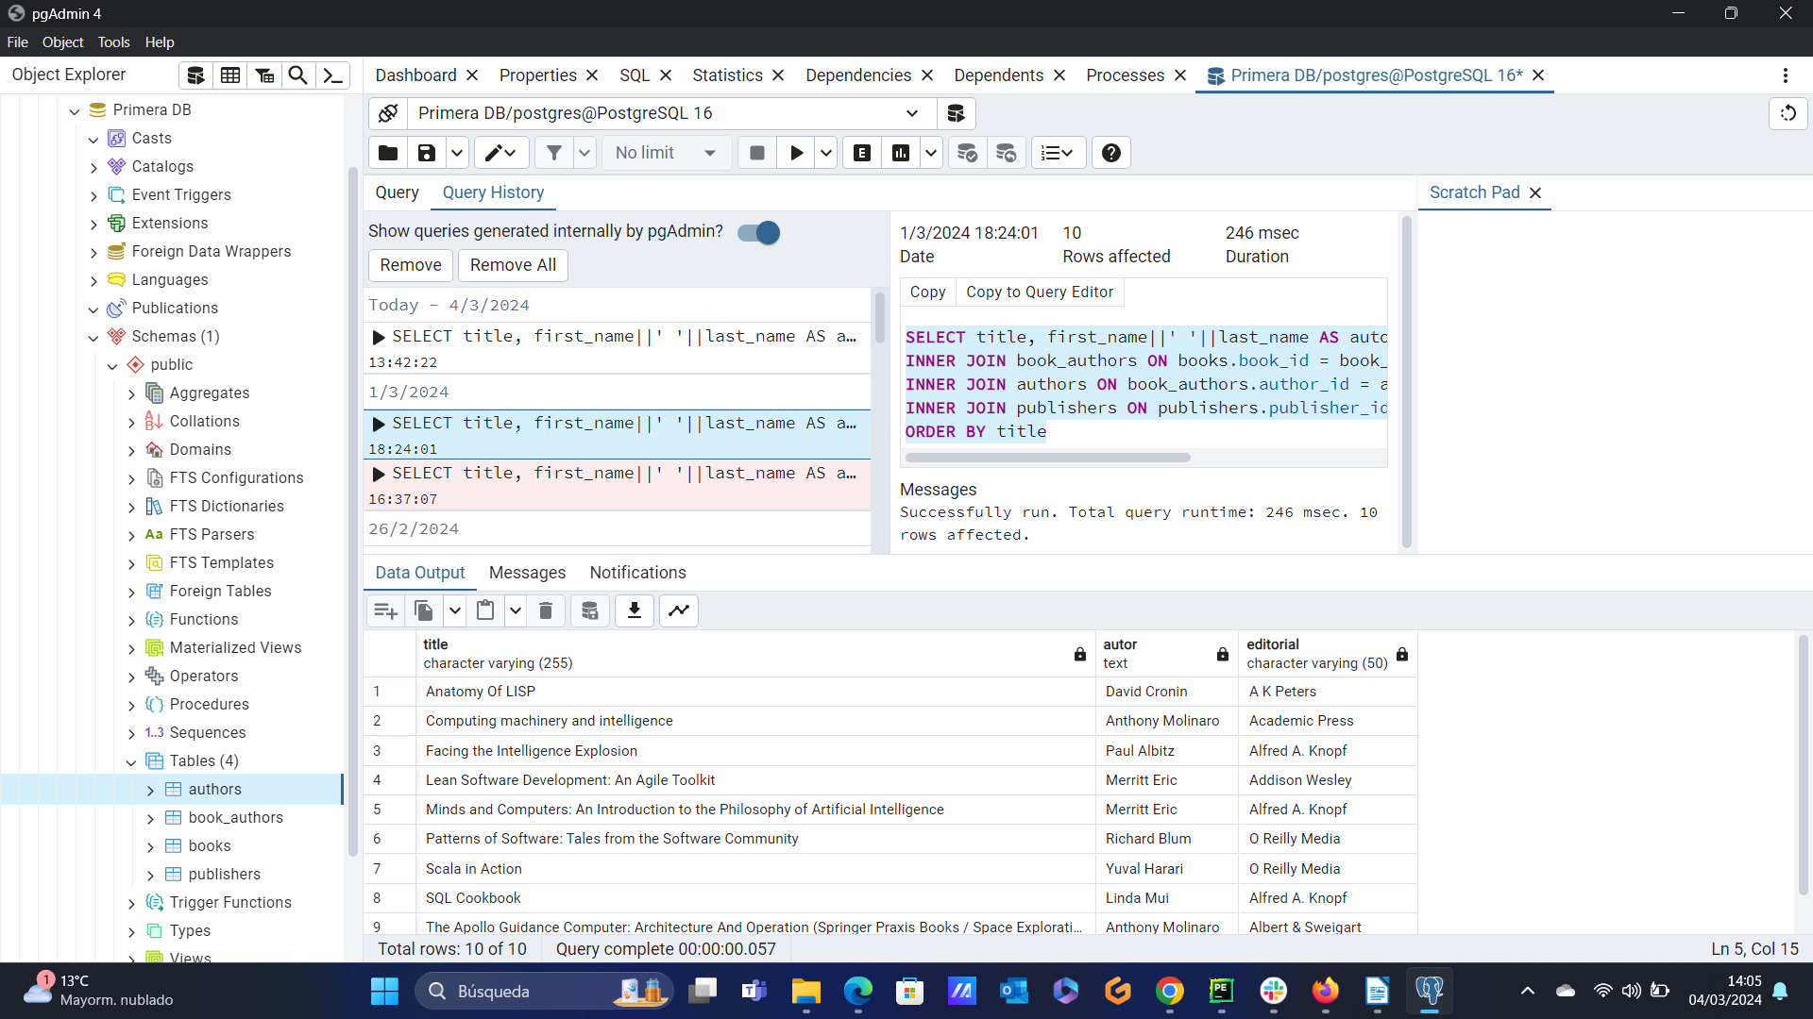

SELECT * FROM publishers

SELECT * FROM authors

SELECT * FROM books

SELECT first_name FROM authors
WHERE middle_name IS NOT NULL

SELECT first_name, last_name FROM authors
WHERE middle_name IS NULL

SELECT first_name||' '||middle_name||' '||last_name
FROM authors
WHERE middle_name

SELECT first_name||' '||last_name
FROM authors
WHERE middle_name IS NULL

SELECT first_name||' '||last_name AS nombre_completo
FROM authors
WHERE middle_name IS NULL

SELECT first_name||' '||last_name AS nombre_completo
FROM authors

SELECT title, published_date, name
FROM books
INNER JOIN publishers ON books.publisher_id = publishers.publisher_id

SELECT title, published_date, name
FROM books
INNER JOIN publishers ON books.publisher_id = publishers.publisher_id
WHERE name = 'Albert&Sweigart'

SELECT title, published_date, name
FROM books
INNER JOIN publishers ON books.publisher_id = publishers.publisher_id
WHERE name = 'Alfred A. Knopf'

SELECT title, published_date, name
FROM books
INNER JOIN publishers ON books.publisher_id = publishers.publisher_id
WHERE name = 'Alfred A. Knopf'
ORDER BY published_date ASC

SELECT title, first_name||' '||last_name AS autor FROM books
INNER JOIN book_authors ON books.book_id = book_authors.book_id
INNER JOIN authors ON book_authors.author_id = authors.author_id

SELECT title, first_name||' '||last_name AS autor FROM books
INNER JOIN book_authors ON books.book_id = book_authors.book_id
INNER JOIN authors ON book_authors.author_id = authors.author_id
WHERE EXTRACT(YEAR FROM published_date) < 2000
ORDER BY published_date ASC

SELECT title, first_name||' '||last_name, published_date AS autor FROM books
INNER JOIN book_authors ON books.book_id = book_authors.book_id
INNER JOIN authors ON book_authors.author_id = authors.author_id
WHERE EXTRACT(YEAR FROM published_date) < 2000
ORDER BY published_date ASC

SELECT title, first_name||' '||last_name AS autor, name, published_date FROM books
INNER JOIN book_authors ON books.book_id = book_authors.book_id
INNER JOIN authors ON book_authors.author_id = authors.author_id
INNER JOIN publishers ON publishers.publisher_id = books.publisher_id
ORDER BY published_date ASC

SELECT title, first_name||' '||last_name AS autor, name, published_date FROM books
INNER JOIN book_authors ON books.book_id = book_authors.book_id
INNER JOIN authors ON book_authors.author_id = authors.author_id
INNER JOIN publishers ON publishers.publisher_id = books.publisher_id
ORDER BY title

SELECT title, first_name||' '||last_name AS autor, name AS editorial, published_date FROM books
INNER JOIN book_authors ON books.book_id = book_authors.book_id
INNER JOIN authors ON book_authors.author_id = authors.author_id
INNER JOIN publishers ON publishers.publisher_id = books.publisher_id
WHERE first_name||' '||last_name LIKE 'A%' AND name = 'Albert&Sweigart'
ORDER BY published_date

SELECT title, first_name||' '||last_name AS autor, name AS editorial, published_date FROM books
INNER JOIN book_authors ON books.book_id = book_authors.book_id
INNER JOIN authors ON book_authors.author_id = authors.author_id
INNER JOIN publishers ON publishers.publisher_id = books.publisher_id
WHERE first_name||' '||last_name NOT LIKE 'A%' AND name = 'Albert&Sweigart'
ORDER BY published_date

SELECT title, first_name||' '||last_name AS autor, name AS editorial, published_date FROM books
INNER JOIN book_authors ON books.book_id = book_authors.book_id
INNER JOIN authors ON book_authors.author_id = authors.author_id
INNER JOIN publishers ON publishers.publisher_id = books.publisher_id
WHERE first_name||' '||last_name LIKE 'A%' AND name = 'Albert&Sweigart'
ORDER BY published_date

SELECT title, first_name||' '||last_name AS autor, name AS editorial, published_date FROM books
INNER JOIN book_authors ON books.book_id = book_authors.book_id
INNER JOIN authors ON book_authors.author_id = authors.author_id
INNER JOIN publishers ON publishers.publisher_id = books.publisher_id
ORDER BY name

DROP TABLE IF EXISTS tabla

DROP TABLE publishers

DROP TABLE book_authors

CREATE TABLE IF NOT EXISTS book_authors (
book_id INT NOT NULL,
author_id INT NOT NULL,
PRIMARY KEY(book_id, author_id),
CONSTRAINT fk_book FOREIGN KEY(book_id) REFERENCES books(book_id) ON DELETE CASCADE,
CONSTRAINT fk_author FOREIGN KEY(author_id) REFERENCES authors(author_id) ON DELETE CASCADE
);

INSERT INTO book_authors (book_id, author_id) VALUES (1, 1);
INSERT INTO book_authors (book_id, author_id) VALUES (2, 8);
INSERT INTO book_authors (book_id, author_id) VALUES (3, 7);
INSERT INTO book_authors (book_id, author_id) VALUES (4, 6);
INSERT INTO book_authors (book_id, author_id) VALUES (5, 5);
INSERT INTO book_authors (book_id, author_id) VALUES (6, 4);
INSERT INTO book_authors (book_id, author_id) VALUES (7, 3);
INSERT INTO book_authors (book_id, author_id) VALUES (8, 2);
INSERT INTO book_authors (book_id, author_id) VALUES (9, 4);
INSERT INTO book_authors (book_id, author_id) VALUES (10, 1);

UPDATE publishers SET name = 'Albert & Sweigart'
WHERE publisher_id = 6

SELECT COUNT(title) FROM books WHERE isbn IS NULL

SELECT book_id, title FROM books WHERE isbn IS NULL

SELECT middle_name, COUNT(*) FROM authors GROUP BY middle_name

SELECT name, COUNT(title) AS n_libros, MAX(total_pages) AS mas_gordo, MIN(total_pages) AS mas_fino
FROM books
INNER JOIN publishers ON books.publisher_id = publishers.publisher_id
GROUP BY name

SELECT title, first_name||' '||last_name AS autor, name AS editorial FROM books
INNER JOIN publishers ON books.publisher_id = publishers.publisher_id
INNER JOIN book_authors ON books.book_id = book_authors.book_id
INNER JOIN authors ON authors.author_id = book_authors.author_id
WHERE isbn IS NULL

